**Project Documentation:**

**Week 2 – Task 2:**

***Restaurant Reservation Form***

**Submitted By: Zara Khan**

**Submitted To: A&D Tech**

**Dated: 12th July, 2024**

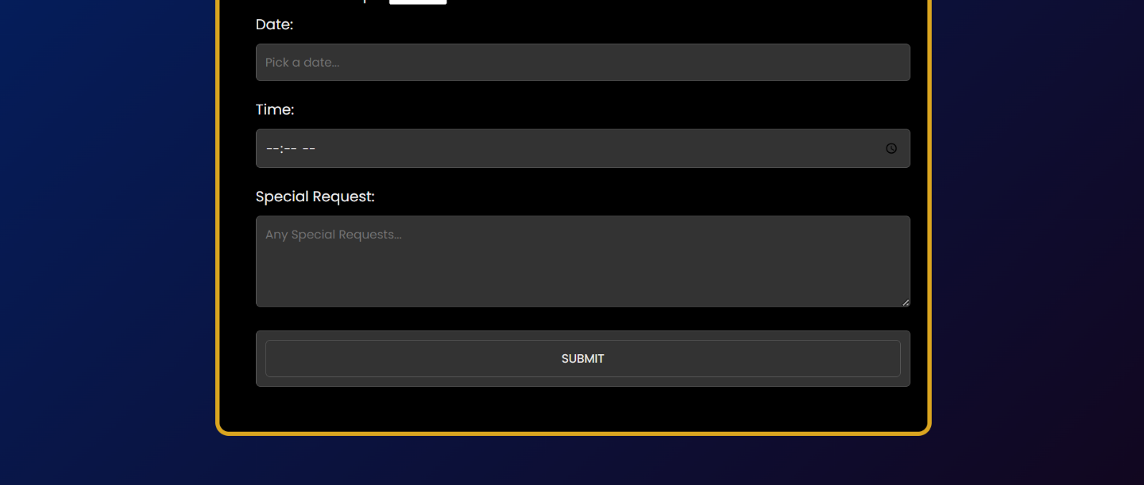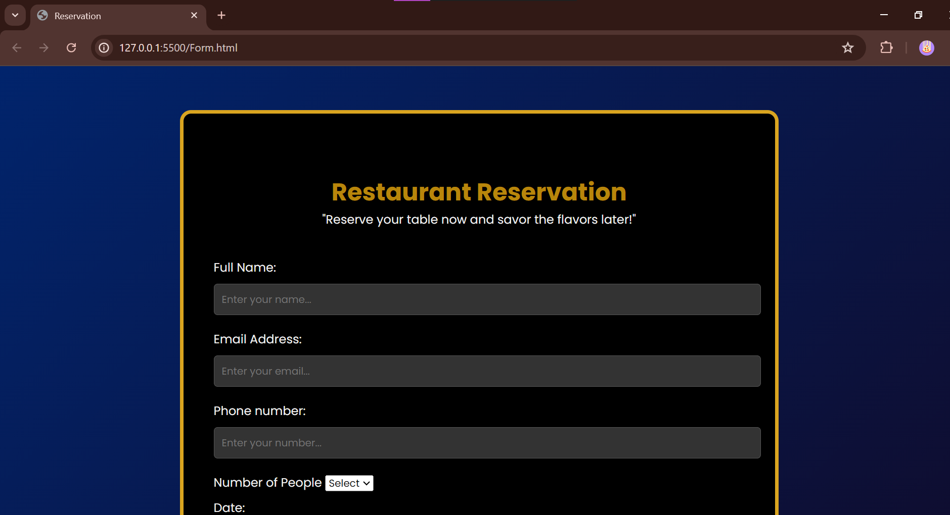

***Cart:***

***Date Feature using Pikaday:***

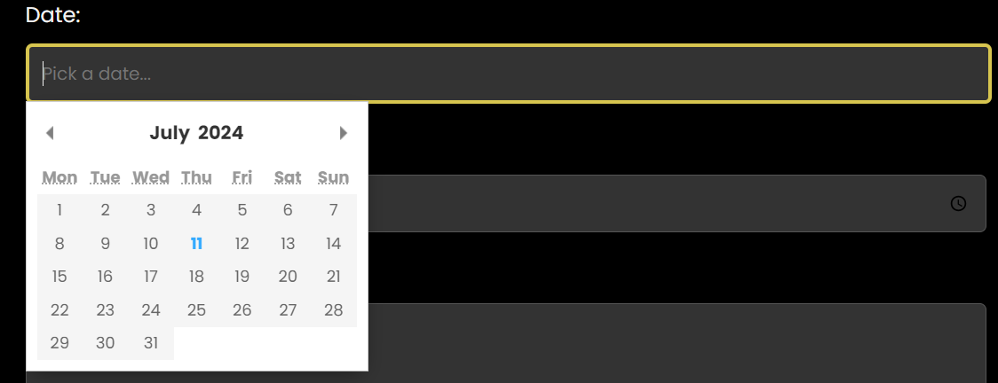

***Validation:***

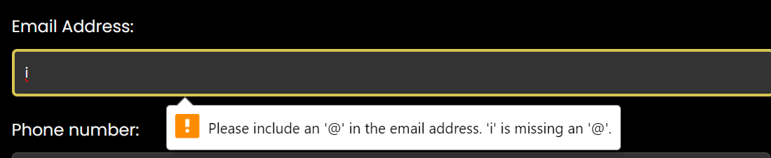

***Time:***

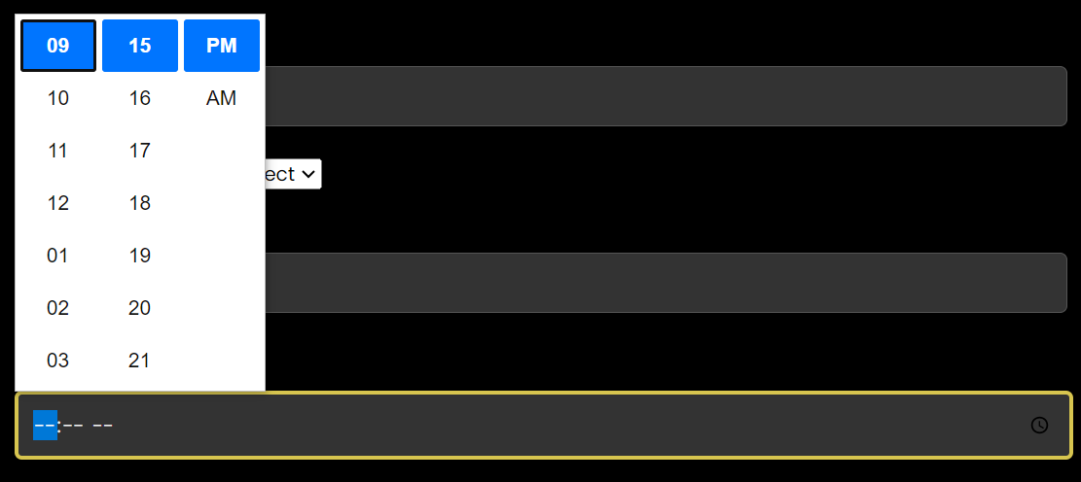

***Hover and Input focus:***

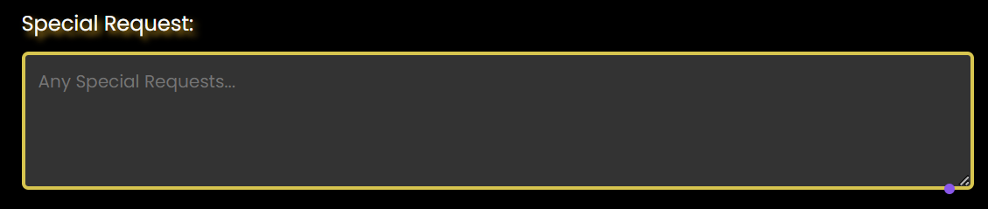

***Responsiveness:***

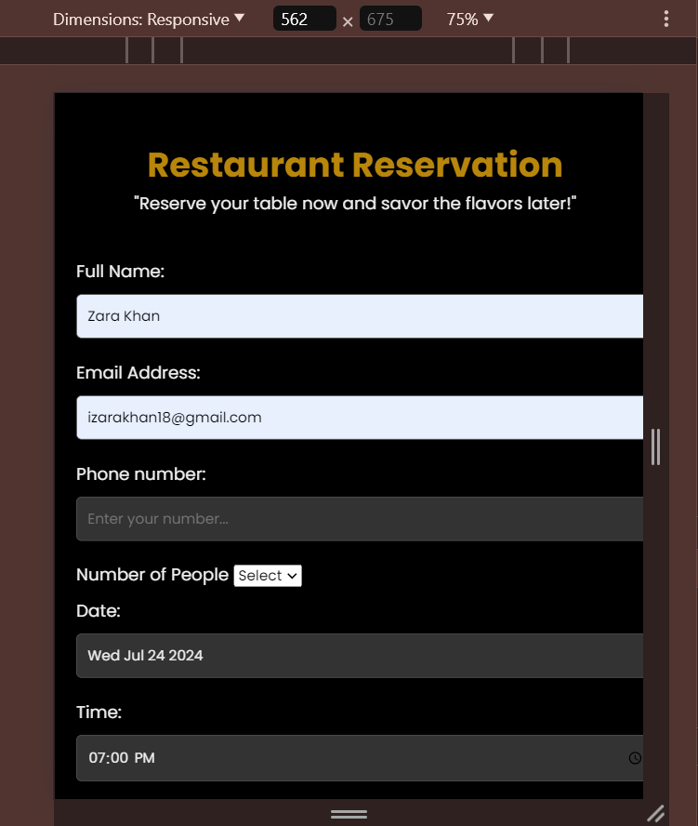

***Problem Statement***

Develop a form for restaurant reservations. This form should not only gather necessary information but also provide an interactive calendar to select a date and time for the booking.

***Solution Overview***

I approached the project by using a dark theme background and creating a form in the center. Added some input fields to gather information and added hover and input focus using CSS. The Date picker feature was added using Pikaday.js.

***Challenges and Resolutions***

* **Challenge: Responsiveness**
* First I created a background using Figma that would look good with the form but it was not responsive. I tried everything to make it responsive across all screens but nothing worked.



* **Resolution:** Had to use a simple linear gradient technique.

***Instructions***

**Setting Up the Project**

1. **Download the Project Files:**
   * Clone the repository from [GitHub link].
   * Alternatively, download the project zip file and extract it to your local machine.
2. **Open in Visual Studio Code (VS Code):**
   * Launch VS Code.
   * Open the entire project folder using File > Open Folder.

**Running the Project**

1. **Navigate to the Main Page:**
   * In the VS Code sidebar, locate and open Form.html.
2. **Filling the Form:**
   * Fill the form and check information and validity along with the date picker functionality.
3. **Testing Responsiveness:**
   * Use VS Code's built-in preview or open the website in different browsers and devices to ensure responsiveness.